REINFORCEMENT PROJECT-4

CAR PERDICTION – POWER BI

INSIGHTS

Sangeetha .N

DA&DS

FEB-25

**INTRODUCTION**

This is an dataset of various car along with their name, brand, engine type and price over the years, which appears to be used for predicting car prices based on various attributes. Here's a quick overview of the dataset's structure:

Data Information

* **Car ID** – A unique identifier assigned to each car entry in the dataset.
* **Brand** – The manufacturer or make of the car (e.g., Toyota, Ford).
* **Model** – The specific name or series of the car produced by the brand.
* **Mileage** – The total distance the car has traveled, typically measured in kilometers or miles.
* **Transmission** – The type of gearbox system, such as manual or automatic.
* **Price** – The selling price of the car at the time of sale.
* **Engine Size** – The capacity of the car’s engine, usually in liters (L) or cubic centimeters (cc).
* **Fuel Type** – The kind of fuel the car uses, such as petrol, diesel, electric, or hybrid.
* **Year** – The year in which the car was sold or manufactured.
* **Condition** – The overall state of the car, like new, used, or certified pre-owned.

**Additional Information:**

* **Brand & model –Concatenate the Brand and Model Columns**
* **Engine Category –Categorize the Engine type Based on Litres**
* **Cylinder Count – To examine the cylinder to run the car**

**DATA PREPARATION**

**Country Wise Analysis chart**

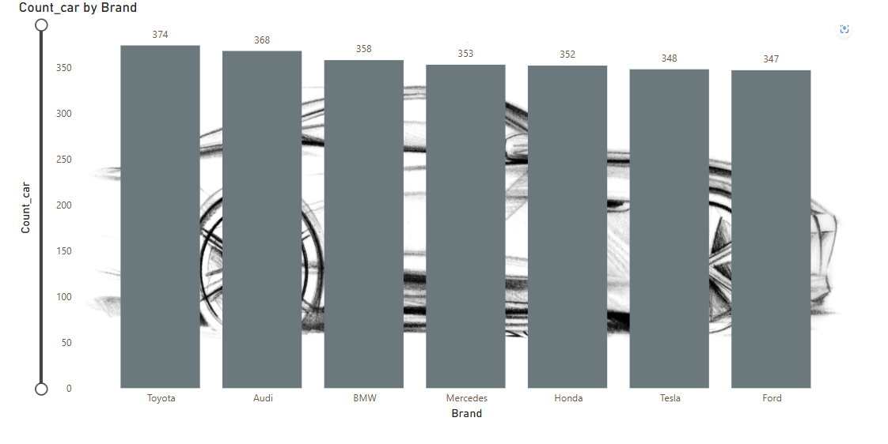

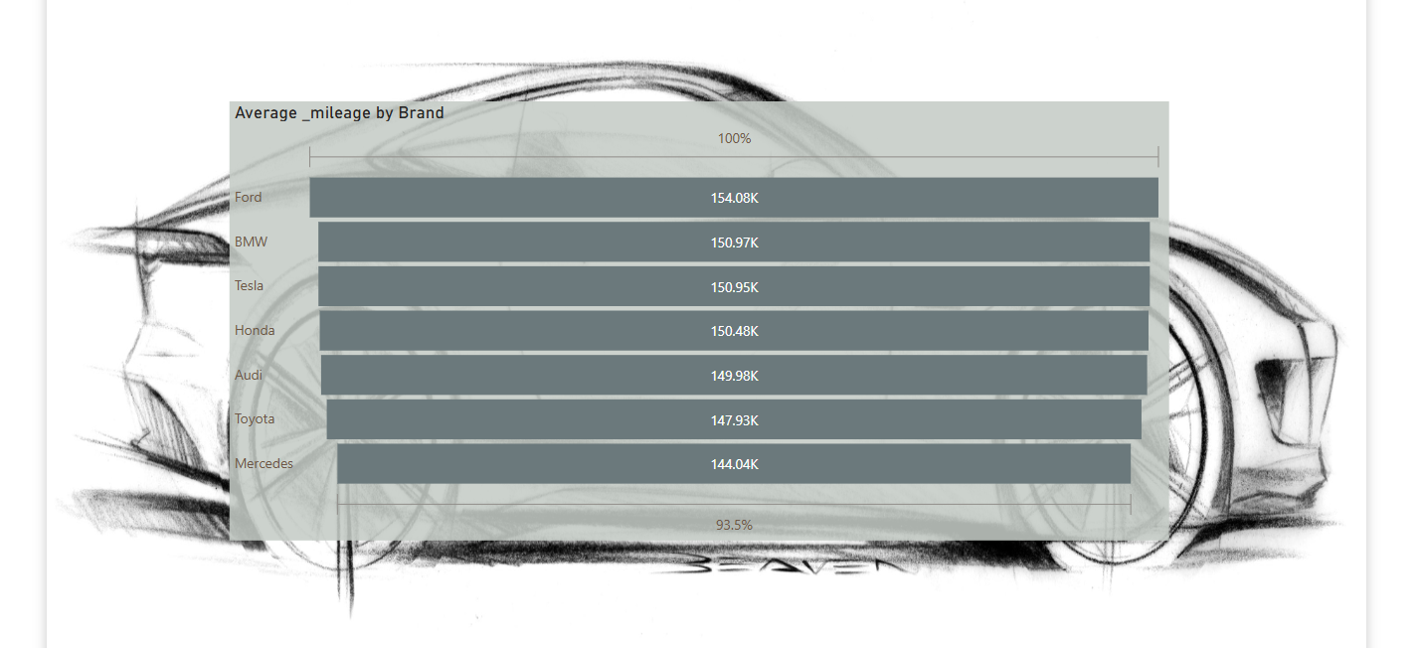Mile

Mileage wise Analysis

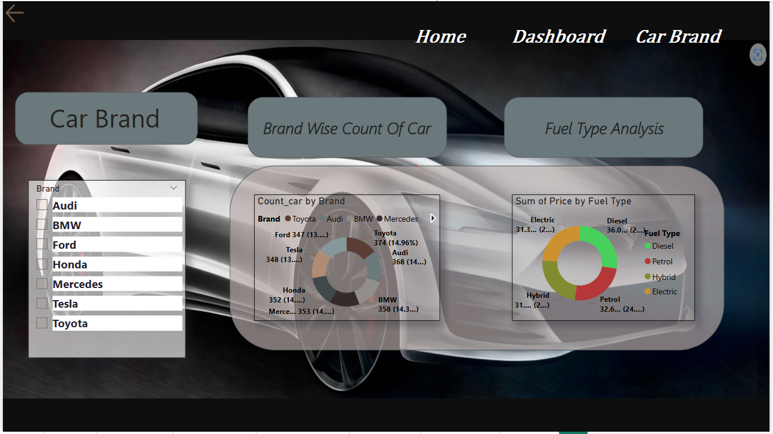

Insights

* **"Most people tend to buy used cars rather than new ones due to affordability and better value for money."**
* **Manual transmission is often preferred for better control and fuel efficiency.**
* **Automatic transmission is favored for ease of use, especially in heavy traffic or urban areas.**
* **Among the car brands in the dataset, Toyota has the highest number of entries across various price points, followed by BMW, Audi, Tesla, Honda, and Ford.**
* **This suggests that Toyota offers a wide range of models catering to different price segments, making it more prevalent in the market."**
* **In the dataset, diesel cars appear most frequently, followed by petrol, hybrid, and then electric vehicles. This order reflects traditional market trends, where diesel and petrol have historically dominated, while hybrid and electric cars are growing but still less common in comparison."**
* **Toyota has the highest total value in car prices, while Ford has the lowest, suggesting Toyota offers more high-priced models compared to others."**

Conclusion:

* Luxury vehicles maintain strong resale value but are increasingly competing with high-end non-luxury models.
* Electric vehicles (EVs) are gaining traction, with Tesla models showing steady growth in price retention and consumer interest.
* SUVs continue to dominate the market, holding higher resale prices and proving to be preferred over sedans.
* Mid-range brands like Toyota, Honda, and Ford remain stable, showing consistent price retention without drastic fluctuations.
* Mileage plays a crucial role in price determination, with hatchbacks seeing the highest usage and luxury sedans having lower mileage but maintaining value.
* Fuel type impacts pricing trends, with EVs and hybrids expected to see continued appreciation, while diesel and petrol models may decline in market demand.
* Manual transmissions still hold value, though automatic transmissions are steadily overtaking them in overall sales.
* Future pricing trends indicate a shift toward EV adoption, luxury expansion into mid-range markets, and continuous growth in SUV popularity.

**RECOMMENDATIONS**

1. Investment in EVs: With Tesla models showing strong price retention and growing demand, investing in EV infrastructure and newer models will likely yield long-term benefits.
2. Luxury Segment Strategies: Given the narrowing price gap between luxury and non-luxury cars, manufacturers should enhance brand differentiation through premium features and after-sales services.
3. SUV Market Optimization: Since SUVs remain strong in pricing, manufacturers should focus on fuel-efficient SUVs and hybrid models to meet demand trends.
4. Manual vs. Automatic Considerations: While manual cars have a slightly higher total price, the gap is narrow, signaling that automatic transmissions will continue to dominate the market in future vehicle designs.
5. Mid-Range Vehicle Stability: Given Toyota, Honda, and Ford's steady pricing, targeting affordable financing options will maintain market share among budget-conscious consumers.

**Price Trend Prediction for Future (2025–2030)**

1. EV Growth Acceleration: Tesla, Toyota, and BMW will see continued demand for electric and hybrid models, making EVs one of the highest-valued segments in pricing.
2. SUV Domination Continues: Expect SUV models to remain the preferred choice, with demand increasing for fuel-efficient and electric SUVs.
3. Sedan Prices Might Decline: Traditional sedans will gradually lose market share to SUVs and EVs, leading to potential depreciation in sedan pricing.
4. Luxury Brands Expanding to Mid-Range: With luxury cars becoming more accessible, brands like BMW and Mercedes may introduce budget-friendly variants to compete with mid-tier brands.
5. Fuel Economy and Smart Features Will Drive Pricing: Expect higher prices for models with advanced AI-based features and fuel efficiency enhancements, with hybrid vehicles holding steady pricing as a bridge between traditional fuel models and EVs.